What is the Nationality and Borders Bill and why was it introduced?

The Nationality and Borders Bill (first introduced in July 2021) will essentially introduce a two-tier system for asylum-seekers arriving in the UK, differentiating between those entering by legal routes, like resettlement, and those arriving spontaneously or having passed through other countries deemed safe. Those in the latter category will be classified as ‘Group 2’ refugees, with restricted rights to remain in the UK, family reunification and financial support.
It's received widespread criticism from the Law Society in England and Wales, the UN Refugee Council, the joint parliamentary committee on human rights and civil society – who’ve all pointed out that the Bill undermines the principle of asylum protection in the UK and the basic tenets of the 1951 Refugee Convention - i.e. that how someone arrives should have no influence on whether they have a right to make an asylum claim, or whether they are later recognised as a refugee. The Home Office Minister Tom Pursglove also confirmed last month that if Ukrainian refugees arrived in the UK via an unofficial route, they could face jail or be sent to offshore processing camps.
In March, The House of Lords voted to remove several controversial clauses from the Bill, including the two-tier system, the power for the Home Secretary to strip British nationals of citizenship without notice and offshore processing camps of refugee and asylum seekers. The Bill then returned to the House of Commons where MPs considered the amendments made by peers. MPs largely rejected the changes proposed by the House of Lords and while the legislation will return to the Lords for further debate in early April, it is expected that the Bill will receive Royal Assent later in April.
On 14 April 2022, the Government announced a deal to off-shire asylum seekers to Rwanda. The Joint Council for the Welfare of Immigrants has said that “These unspeakably cruel plans play fast and loose with the lives of refugees and will put people in danger. The situation in Rwanda for LGBTQI+ people, for example, is so poor that the UK accepts Rwandan refugees on the basis of their sexuality.”
Across the Europe and the US anti-migrant rhetoric has been on the rise. But research by Deutche Bank (with data from OCED) shows that the perceived and actual numbers of immigration have a large disparity. Full Fact state that about a quarter of people say immigration is the most important issue facing Britain today and 4 in 10 say immigration is one of the most important issues—more than any other single issue.

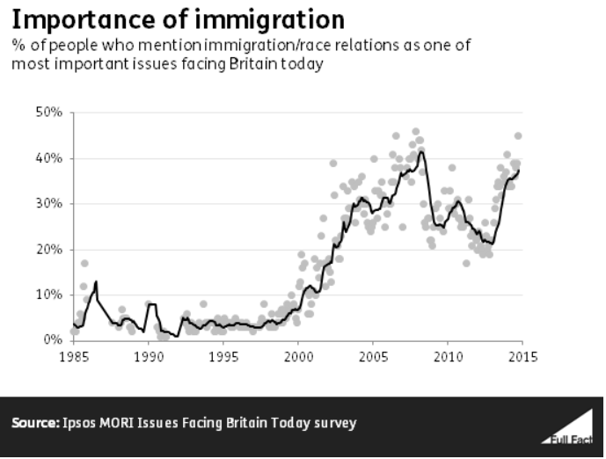
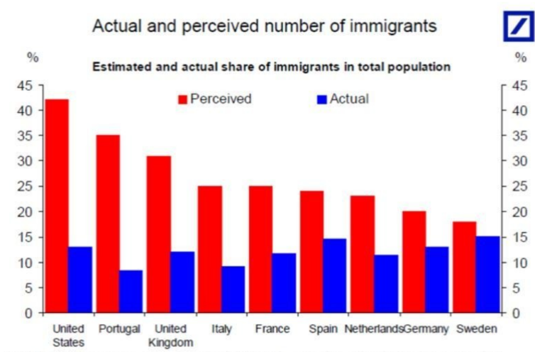

Image: Deutch Bank

What does this mean for London and Londoners?
Just over one third of the UK’s migrants live in London, which includes migrants who have lived here for many years and their children who may be born here. Over one third (37%) of Londoners were born outside of the UK, and over half (54%) of Londoners born abroad don’t hold a British passport, including many EU citizens who had not, pre-Brexit, felt the need to apply for one.
In 2020 non-EU migrants typically had come to the UK for family reasons, followed by work, study and asylum. In London they were less likely to have come for family reasons and more likely to have come for work or asylum than in other parts of the UK.
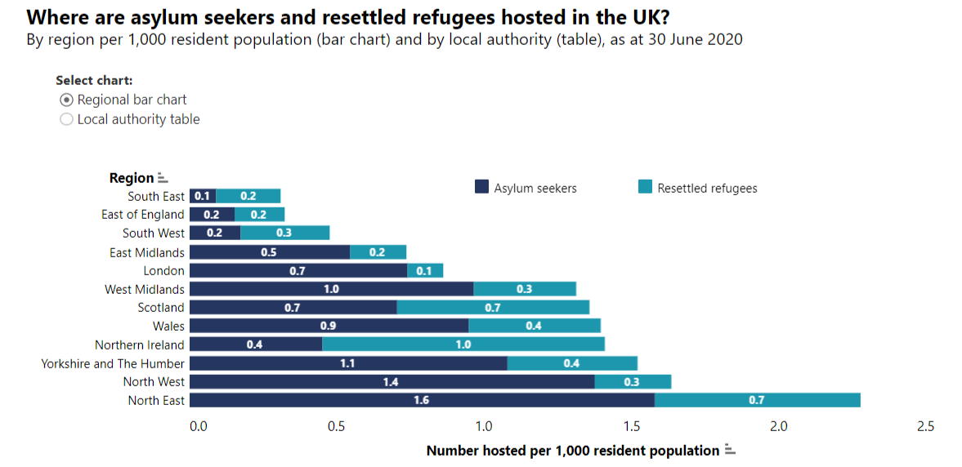
The distribution of asylum-seekers and resettled refugees across the UK is not the same as other types of migrants (Figure to the left). This is due in part to the government’s ‘dispersal’ policy, which distributes the responsibility of hosting asylum-seekers away from London and the South East (Brokenshire, 2015 in Politowski and McGuinness, 2016; Bates, 2015). More recent complicating factors include a change in the government’s dispersal policy, which has seen a slightly larger share of asylum seekers housed in London while their claims are pending.

The London Assembly has called the Nationality and Borders Bill a potentially racist, divisive piece of legislation which echoes the ongoing injustices inflicted on the Windrush generation.

Dr Onkar Sahota AM, said: “What makes London great is its openness and its diversity, but this Bill could see two in five people from ethnic minority backgrounds stripped of their citizenship with no warning. This proposed two-tier system is deeply concerning and unacceptable and could make a huge swathe of Londoners second-class citizens in their country. The Government must learn the damning lessons of the Windrush Scandal and scrap this dangerous and divisive Bill.”
Our member Lewisham Council, the first council to awarded ‘borough of sanctuary’ joined other councils across the country and passed a motion calling on the Government to withdraw the Bill in response to concerned residents.

What are funders doing to support immigration advice services and advocacy?

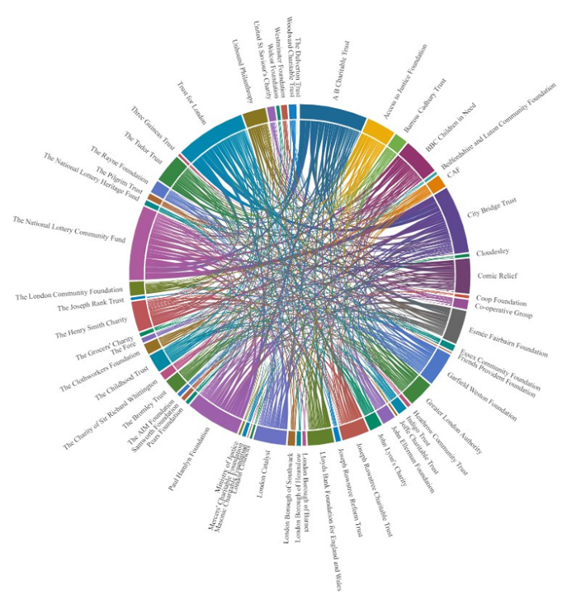
The image to the right is a data visualisation by 360Giving that shows funders making grants to organisations that have received at least one grant for advice to immigrants in London, even if they were not funding the advice work itself or have not included these terms in the grant descriptions. (You can explore this diagram online which will allow you to zoom in to see more detail and interact to see the individual relationships here).
We know through our work with members and partners in developing a strategy for funding immigration advice, that the immigration system is purposefully designed to be hostile, complex and expensive. We’ve already seen an increased demand for immigration advice as a result of changes to law and policy. The vision we set out in the immigration advice strategy was one where the advice sector is supported by long-term, strategic and intelligent funding, which takes account of the frontline advice, effective infrastructure and advocacy for a fairer immigration system. As the Nationality and Borders Bill is set to become law, this vision becomes even more important.
The overlap between immigration advice and other areas of social welfare is strong. But limited access to good immigration advice will increase demand or exacerbate hardship in connected sectors that funders actively support such as children and young people, families, poverty, employment, education, domestic abuse, health, homelessness, criminal justice, strong communities. In effect, if you are a funder in London, poor access to immigration advice is likely to be impacting on your area of interest, and you can’t afford to ignore it. Read more about our recommendations for funders here.

Further reading:

Where do migrants live in the UK, Migration Observatory - https://migrationobservatory.ox.ac.uk/resources/briefings/where-do-migrants-live-in-the-uk/#:~:text=The%20most%20recent%20available%20data,%25)%20(ONS%2C%202021
What concerns the British public about immigration policy?, YouGov - https://yougov.co.uk/topics/politics/articles-reports/2021/11/03/what-concerns-british-public-about-immigration-pol
Is it legal to outsource the UK’s refugee responsibilities to Rwanda?, Colin Yeo (Free Movement) - https://freemovement.org.uk/is-it-legal-to-outsource-the-uks-refugee-responsibilities-to-rwanda/
The impact the Nationality and Borders Bill will have on Ukrainian refugees, Colin Yeo (Free Movement) - https://freemovement.org.uk/imagine-you-are-a-ukrainian-refugee/
Why we need to unite against the Nationality and Borders Bill, Greenpeace - https://www.greenpeace.org.uk/news/unite-against-the-nationality-and-borders-bill/

https://www.jcwi.org.uk/unspeakably-cruel-new-plans-to-send-asylum-seekers-to-rwanda
https://www.weforum.org/agenda/2017/08/this-chart-shows-the-actual-vs-percieved-number-of-immigrants
https://fullfact.org/immigration/public-attitudes-towards-immigration/
https://migrationobservatory.ox.ac.uk/resources/briefings/migrants-in-the-uk-an-overview/
https://migrationobservatory.ox.ac.uk/resources/briefings/where-do-migrants-live-in-the-uk/#:~:text=The%20most%20recent%20available%20data,%25)%20(ONS%2C%202021).
https://migrationobservatory.ox.ac.uk/resources/briefings/where-do-migrants-live-in-the-uk/#:~:text=The%20most%20recent%20available%20data,%25)%20(ONS%2C%202021).
https://www.london.gov.uk/press-releases/assembly/assembly-condemns-borders-bill
https://lewisham.gov.uk/mayorandcouncil/community-support/refugees/migrants-and-refugees
https://asylummatters.org/2022/01/12/fighting-the-anti-refugeebill-in-our-communities/

