What is the 'Refugee Ban Bill’ and when does it come into effect?
The ‘Refugee Ban Bill’ (formally the Illegal Migration Bill) was introduced in the House of Commons in March 2023. Its purpose, according to the Government, is to “prevent and deter unlawful migration, and in particular migration by unsafe and illegal routes, by requiring the removal from the United Kingdom of certain persons who enter or arrive in the United Kingdom in breach of immigration control”.
The Bill had its second reading in late March and is now back with MPs for amendments before returning to Parliament 26 April. The Government has tabled a number of amendments to the Refugee Ban Billto, in their own words “strengthen it further, ahead of it returning to Parliament next week – helping to deliver our priority of stopping the boats.”
The Government has said that it wants to rush this legislation onto the statute book and its proposed timetable for the scrutiny of the Bill reflects this. The Bill will spend two days in the House of Commons before having its third reading and being sent up to House of Lords.
The Government says the Bill will deter people from illegally entering the UK, including those who cross the Channel in dinghies or hide in the backs of lorries, combat people smuggling and make it easier to remove people who do not have a legal right to remain. Ministers say it will also allow for an annual cap on the number of people admitted to the UK under “safe and legal” asylum routes. Suella Braverman has admitted the Government is attempting to push “the boundaries of international law” with legislation aimed at reducing small boat crossings in the Channel.
Earlier this month, the joint committee on human rights heard evidence about whether the Bill is compatible with the UK’s obligations under the European convention on human rights and international human rights and refugee treaties.
Vicky Tennant, the UK representative at the UN high commissioner for refugees (UNHCR), warned that the legislation could have a “domino effect” on other countries. “It’s potentially moving towards the collapse of this international system, which is not in anyone’s interest,” she said. “It would set a really unfortunate precedent.”
She added that at the heart of the refugee convention is a framework in which states agree to cooperate with each other and share responsibility. “You see the UK pulling back from its responsibilities … That is being watched, there’s an impact, there are consequences, that’s very worrying. We have a profile of people coming across the Channel which is largely a refugee profile. The bill is essentially extinguishing their right to asylum. It would cover anyone who arrives in the UK in an unauthorised manner.”
“The solution is in regional cooperation. If we pursue a series of unilateral measures, that pushes responsibility on to other countries, that undermines the trust for the regional cooperation,” she said.
What’s in the Bill?
The Bill imposes a duty on the Home Secretary to make arrangements for the removal of a person from the United Kingdom if they meet four conditions:
- that they entered the UK in breach of immigration laws
- they entered the UK on or after 7 March 2023, meaning that the Bill has retrospective effect
- that they travelled through a safe third country on route to the UK.
- that they require leave to enter or remain, but do not have it
Following on from these, amendments tabled at the second reading would speed up the removal of people with no right to be here and enhance safeguards for unaccompanied children who cross the Channel in small boats.
Tabled amendments added in April include:
- a new clause giving ministers discretion as to whether or not to comply with an interim measure indicated by the European Court of Human Rights (ECtHR) in Strasbourg
- giving immigration officers new powers to search for and seize electronic devices like mobile phones from people who come to the UK illegally – to help them assess whether someone has the right to be in the UK.
- increasing protections around the safeguarding risk caused by adults pretending to be children, by bringing in new regulations that will see age-disputed people treated as an adult if they refuse to undergo a scientific age assessment.
- One is by threatening them with removal, either to their own country or some other safe country, like Rwanda.
- The other intended means of deterrence is by denying access to the asylum system or lawful immigration status to anyone who enters outside normal immigration laws. No asylum seeker entering unlawfully will ever in future be given permission to stay or permission to work and their families, if they have one, will never be allowed to join them lawfully. It does not matter if they are a genuine refugee or not.

Will it work the way the Government intend?
The Home Secretary, Suella Braverman stated: “Enough is enough. The British people want this solved. They are sick of tough talk and inadequate action. We must stop the boats. That’s why myself and the prime minister have been working flat out to bring forward necessary and effective laws which will tackle this problem, once and for all.”
However, according to YouGov polling, 73% of Londoners think the government is handling the issue of immigration in the UK badly and many organisation are speaking out, with some looking at legal action against the government.

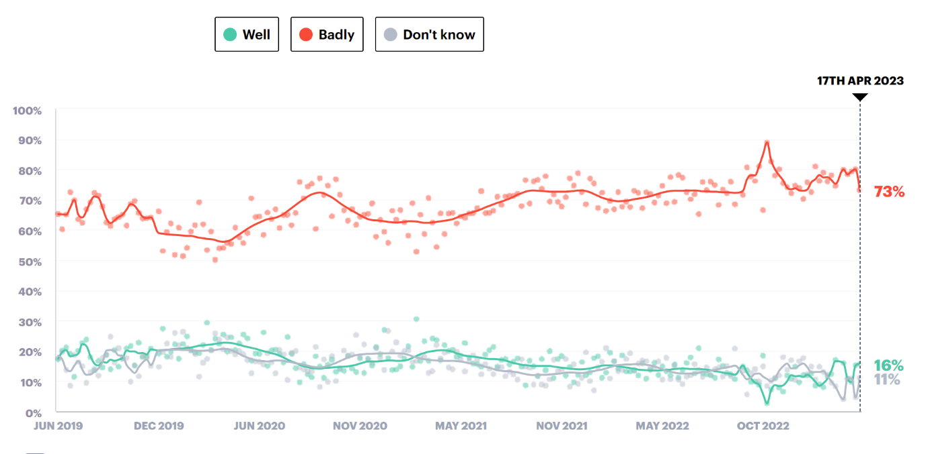
Tim Naor Hilton, chief executive of Refugee Action, said: “The Government’s hateful language and anti-refugee laws simply make the suffering of people worse, most of whom go on to be granted refugee status and become our neighbours, friends and colleagues. The hostile environment, which the anti-refugee laws are part of, is cruel and racist. It must be ditched and replaced with a system built on dignity and compassion so people feel supported to live healthy and productive lives in peace.”
A spokesperson for the Refugee Council stated: “Being subjected to a hostile narrative and treated with suspicion understandably takes its toll on vulnerable people who are hoping to build new lives for themselves. We should be treating refugees with dignity and respect and providing support for their complex needs, instead of causing them further distress and trauma.”
The Law Society president Lubna Shuja said: “As with all legislation, the Law Society’s lens is the rule of law and access to justice. We will analyse carefully whether these principles have guided the Government’s drafting of this bill.
“However, we are concerned that there has been no public consultation, including with lawyers, to ensure the bill is workable, provides due process for those claiming asylum or is compliant with international law.”
According to Matilde Rosina & Oula Kadhum, LSE British Politics and Policy, three challenges stand in its way: the lack of return agreements, the stalling Rwanda plan, and the practical difficulties and costs involved in returning migrants. Ultimately, the new Bill is part of a political game, which nonetheless has real-world consequences for migrants, as well as the narratives and perceptions surrounding refugees and migration more broadly.
They go on to say that “the reality is that, unless the Government creates safe and legal pathways for migrants and refugees to seek asylum, desperate people will continue to make desperate journeys on small boats to seek safety. Choice of destination is often influenced by migrant networks and chain migrations, which have historically been shaped by colonial links and structural inequalities. So long as there is a disconnect between foreign policies and migration policies, and a failure to acknowledge why migrants are turning up in the UK, empty rhetoric is the only tool the government will have to address the "migrant crisis", and many more people will be lost at sea.”

Further reading
Free movement - https://freemovement.org.uk/illegal-migration-bill-better-options/
Liberty Human Rights, - https://www.libertyhumanrights.org.uk/issue/explained-anti-refugee-bill/
UK in a changing Europe - https://ukandeu.ac.uk/explainers/the-illegal-migration-bill/
Institute for Government - https://www.instituteforgovernment.org.uk/publication/illegal-migration-bill
The Law Society - https://www.lawsociety.org.uk/topics/immigration/parliamentary-briefing-illegal-migration-bill-report-stage
YouGov, Immigration - https://yougov.co.uk/topics/politics/explore/issue/Immigration

https://commonslibrary.parliament.uk/research-briefings/cbp-9747/
https://bills.parliament.uk/bills/3429
https://www.gov.uk/government/news/new-measures-to-stop-the-boats-in-illegal-immigration-bill
https://www.instituteforgovernment.org.uk/comment/illegal-migration-bill-legislative-scrutiny
https://www.theguardian.com/uk-news/2023/mar/07/suella-braverman-small-boats-plan-push-boundaries-international-law-rishi-sunak
https://www.theguardian.com/uk-news/2023/mar/29/migration-bill-could-topple-world-refugee-system-mps-told
https://ukandeu.ac.uk/explainers/the-illegal-migration-bill/
https://ukandeu.ac.uk/explainers/the-illegal-migration-bill/
https://ukandeu.ac.uk/explainers/the-illegal-migration-bill/
https://www.gov.uk/government/news/new-measures-to-stop-the-boats-in-illegal-immigration-bill
https://www.theguardian.com/uk-news/2023/mar/05/sunak-to-launch-bill-to-bar-asylum-claims-from-people-arriving-on-small-boats
https://yougov.co.uk/topics/politics/trackers/how-the-government-is-handling-the-issue-of-immigration-in-the-uk?crossBreak=london
https://www.bigissue.com/news/social-justice/illegal-migration-bill-damage-mental-health-asylum-seekers/
https://www.bigissue.com/news/social-justice/illegal-migration-bill-damage-mental-health-asylum-seekers/
https://www.lawsociety.org.uk/topics/immigration/we-respond-to-the-governments-proposed-illegal-migration-bill
https://www.ein.org.uk/blog/can-governments-immigration-bill-succeed#:~:text=On%207%20March%202023%2C%20British,from%20applying%20for%20asylum%20there.

