COP27 – what happened and was it a success?
The final deal "does not bring enough added efforts from major emitters to increase and accelerate their emissions cuts. It does not bring a higher degree of confidence that we will achieve the commitments made under the Paris Agreement and in Glasgow last year," Vice-President Frans Timmermans, who led the negotiations on the EU's behalf, said at the summit's closing plenary.
There has been widespread disappointment recorded following COP27 climate conference in November. It’s been reported there were more than 600 fossil fuel lobbyists at the COP27 this year, a rise of more than 25% from last year and outnumbering any one frontline community affected by the climate crisis.
Despite the lack of agreements on bringing an end to fossil fuel use and explorations, the summit’s main outcome was a historic agreement to set up a brand-new fund for loss and damage, the financial compensations for the countries hardest hit by the climate crisis.
The breakthrough capped over 30 years of demands by vulnerable nations, who disproportionally suffer from extreme weather events despite their limited role in the release of greenhouse gas emissions.
From the agreements made European Commission President Ursula von der Leyen said: "we have treated some of the symptoms but not cured the patient from its fever"
What can funders can do?
The UN has stated “there is no credible path to 1.5C”, we are close to the tipping point of destroying the Amazon, and extreme weather from floods to tornadoes to heatwaves are affecting millions across the globe.
The news can be overwhelming when thinking what difference each of us can make, but if funders have learnt anything over the last few years, it is that collective impact works. We saw during the pandemic how grassroots and mutual aids organisations sprung into action and how funders responded collectively to get the money out the door. Currently in this cost of living crisis funders are pulling together again to share resources, intelligence and putting money into collective pots. So why aren’t we doing it at the scale and speed with the climate crisis?
The Environmental Funders Network latest report, a resource pact for funders, was created as “[they] believe a key reason for inaction by potential funders is the difficulty both in understanding this complex issue and in navigating the wide range of initiatives underway around the world to drive change guides funders.”
In this report they cover how funders can begin to take action and explains the difference between mitigation, adaptation and/or loss and damage funding. With one of their key steps to taking action is to: “start funding at the place where climate change affects the causes you’re passionate about”.
It’s important here to stress the intersectionality of climate funding, as Active Philanthropy states in their report Funding the Future: How the climate crisis intersects with your giving: “funders are increasingly interested in addressing systemic challenges and fostering long-term change to achieve a just world…Yet climate change risks undermining these efforts. Climate change reinforces existing inequalities on a global and local level, and its causes and impacts have great implications for justice.”
They detail five areas where climate change intersects with other funding streams:
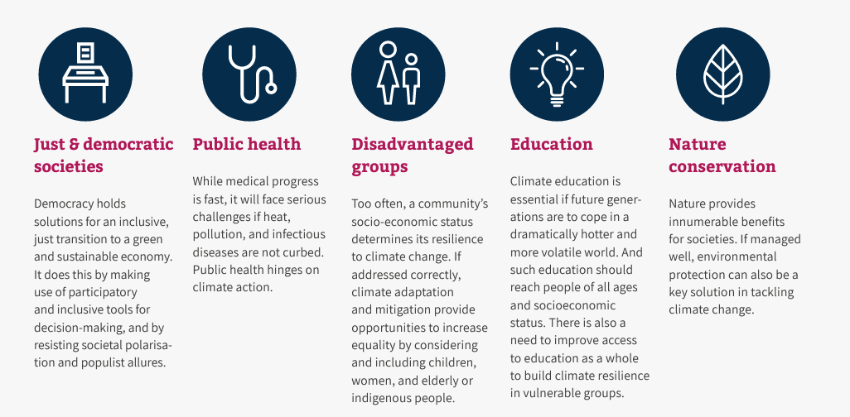

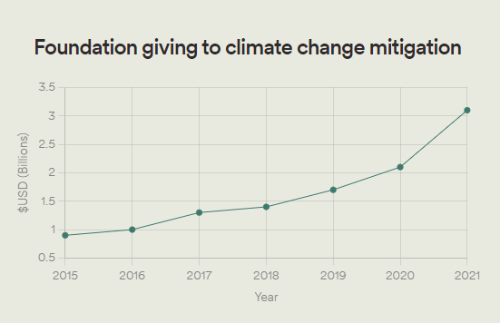
This is echoed by Climateworks foundation who state: “As the climate crisis intensifies, it will increasingly have implications for public health, food security, biodiversity, economic equity, and racial and social justice. These intersections call for innovative approaches and solutions from the philanthropic sector, including funders new to climate but with expertise on issues that may have been traditionally underemphasized in that space.”
Having recently published their third annual report on funding trends in climate change mitigation philanthropy globally and covers seven years of funding data from 2015 to 2021. The good news is that climate change mitigation funding is on an upwards trend, there is a growing emphasis on equity and justice and increased collaboration. You can read more about actions funders can take in our 2021 insight briefing on the climate crisis here.

Further reading:
Emissions Gap Report 2022, UN - https://www.unep.org/resources/emissions-gap-report-2022
London Climate Change partnership - https://climatelondon.org/
Climate Change, London Councils - https://www.londoncouncils.gov.uk/our-key-themes/climate-change
Funder commitment on Climate Change, ACF - https://fundercommitmentclimatechange.org/
Green Climate Fund - https://www.greenclimate.fund/about
Friends of the earth - https://friendsoftheearth.uk/
Climate and environmental leadership principles, ACEVO - https://www.acevo.org.uk/influencing/climate-emergency/climate-principles/
Acting on the Climate Crisis: Why, How and the Role of Philanthropy A resource pack for funders - https://www.greenfunders.org/acting-on-the-climate-crisis-why-how-and-the-role-of-philanthropy-a-resource-pack-for-funders/
Climate Philanthropy Guide, Active Philanthropy - https://www.activephilanthropy.org/climate-philanthropy-guide
Climateworks Foundation - https://www.climateworks.org/report/funding-trends-2022/
Much alarm, less action, Centre for Effective Philanthropy - https://cep.org/report-backpacks/much-alarm-less-action/?section=stats#stats

https://www.euronews.com/my-europe/2022/11/21/cop27-eu-left-disappointed-by-lack-of-ambition-in-final-deal-calling-it-a-small-step-forwa
https://www.theguardian.com/environment/2022/nov/10/big-rise-in-number-of-fossil-fuel-lobbyists-at-cop27-climate-summit
https://www.unep.org/resources/emissions-gap-report-2022
https://news.mongabay.com/2022/10/the-amazon-will-reach-tipping-point-if-current-trend-of-deforestation-continues/#:~:text=The%20tipping%20point%2C%20according%20to,eastern%2C%20southern%20and%20central%20Amazon.
https://theconversation.com/2022s-supercharged-summer-of-climate-extremes-how-global-warming-and-la-nina-fueled-disasters-on-top-of-disasters-190546#:~:text=The%20Northern%20Hemisphere's%20extreme%20summer,an%20estimated%2033%20million%20people.
chrome-extension://efaidnbmnnnibpcajpcglclefindmkaj/https://londonfunders.org.uk/sites/default/files/uploads/4ii_LCR%20Learning%20Reports_Delivering%20Differently_Spread.pdf
https://londonfunders.org.uk/resources-publications/publications/cost-living-crisis-how-are-funders-responding

